Lower Granite: Kelt upgrades to existing JFF

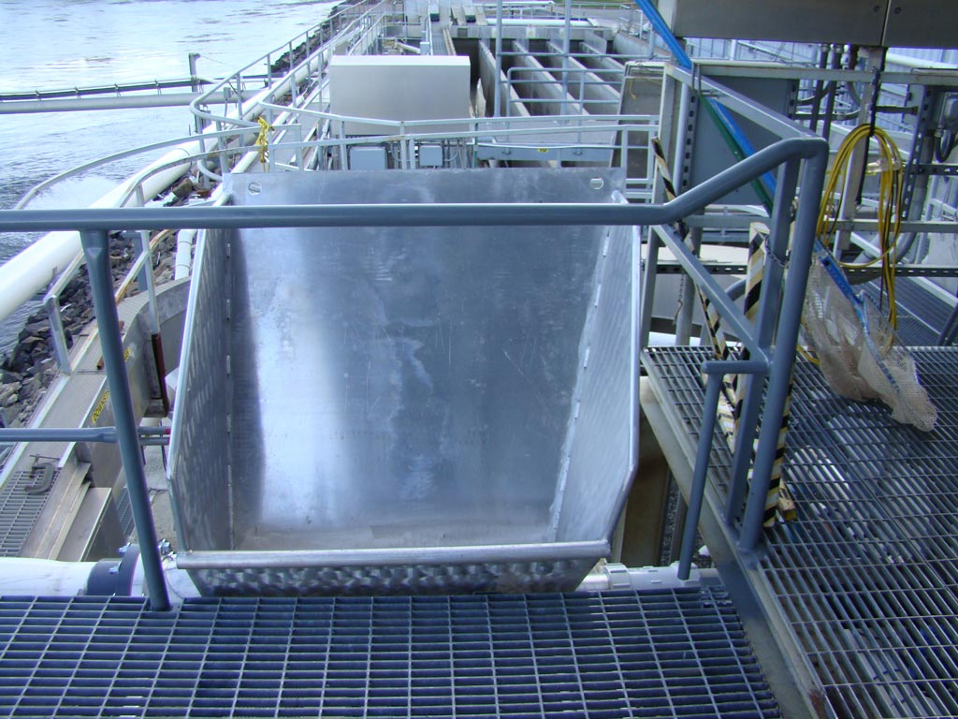
small bin used to route kelts from the separator into the pipe
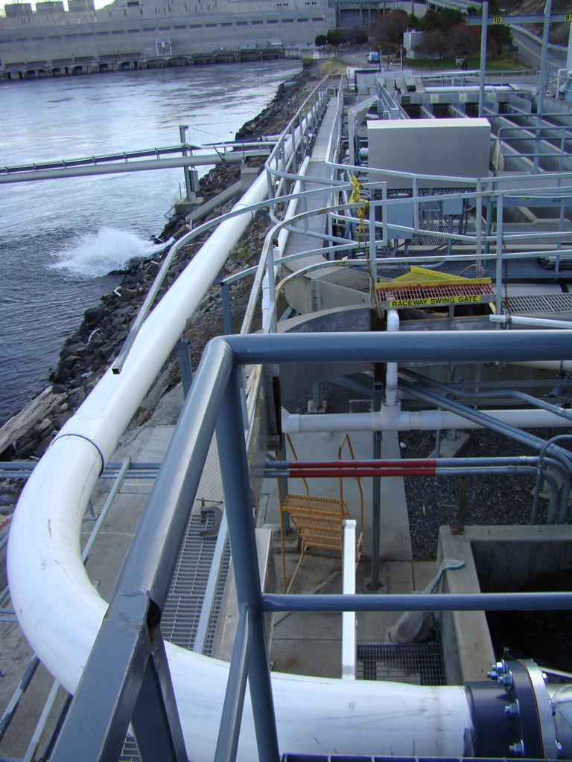
10-inch pipe from the routing bin to the holding tanks
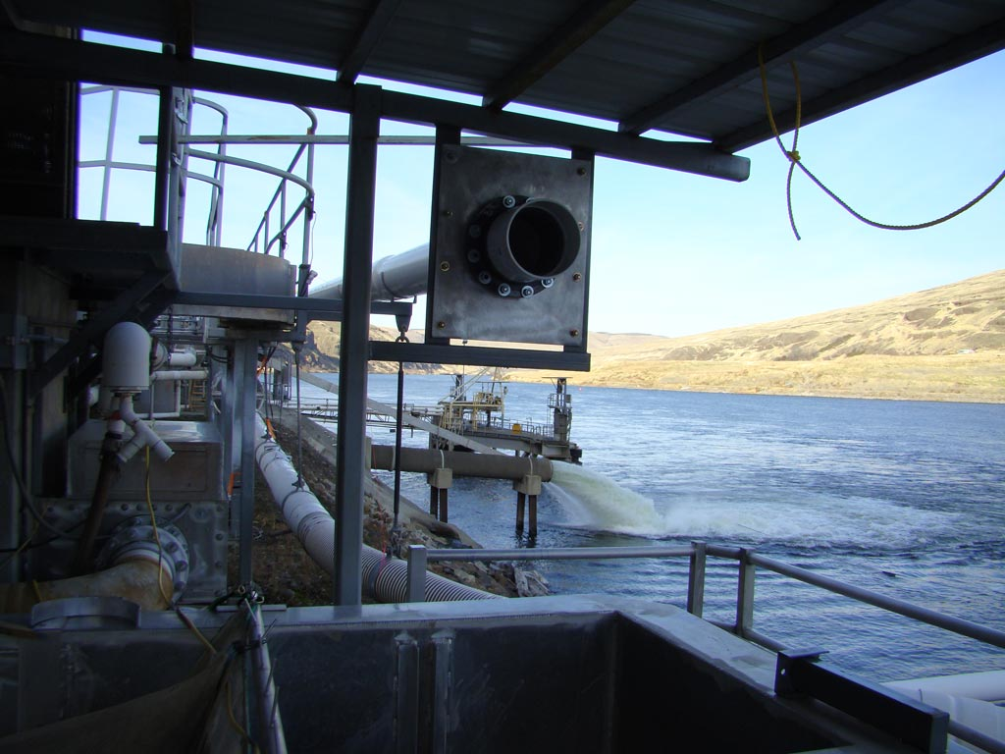
Present end of the kelt pipe. Will finish when tanks from UI arrive.
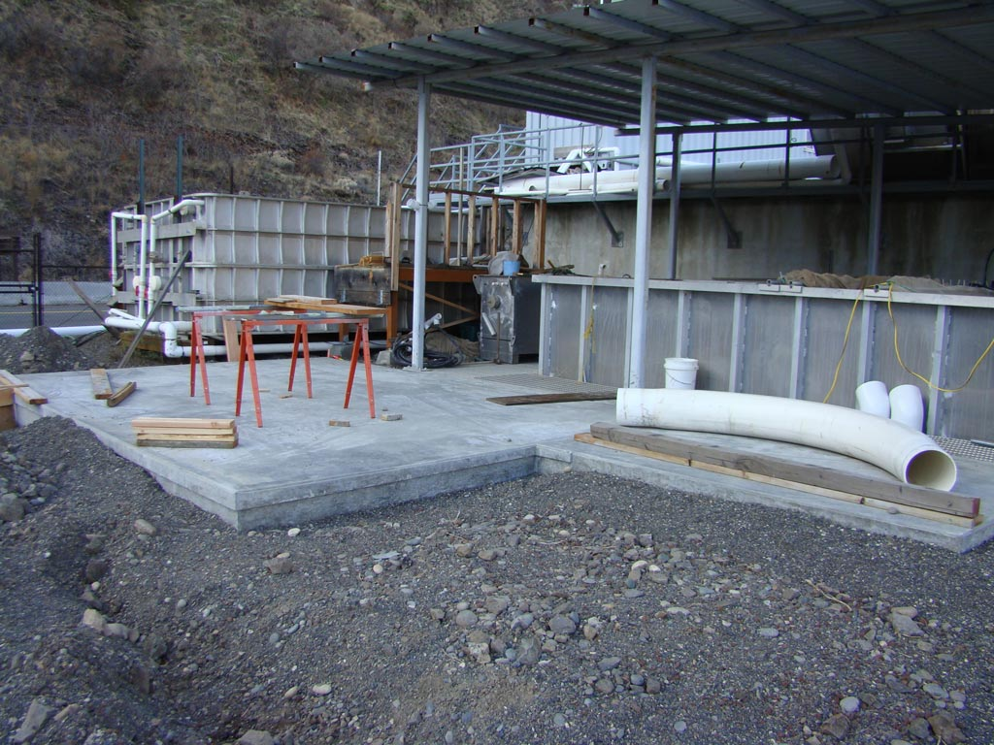
Concrete pads for the two kelt tanks
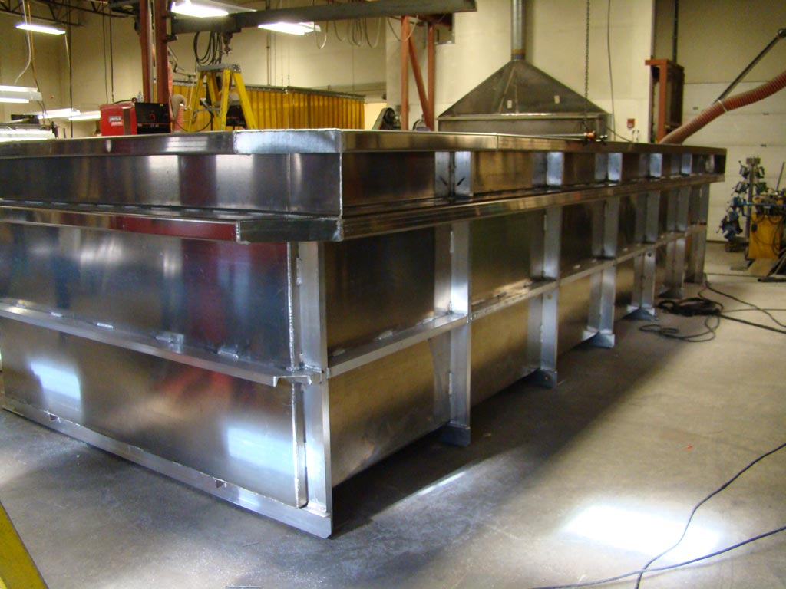
Kelt tank under construction at the UI

